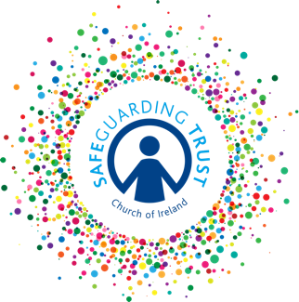

Booterstown and Carysfort with Mount Merrion Grievance Procedure for Volunteers
Booterstown and Carysfort with Mount Merrion Parishes are committed to providing a safe and happy work environment for volunteers.

This grievance procedure aims to deal in a fair, prompt and impartial manner with the grievances of individual volunteers in relation to their role or duties.

Most difficulties can be dealt with through the normal channels of communication within a parish. Where this is not possible, the purpose of this grievance procedures is to provide for the orderly resolution of the issues in a fair and open way.

Informal discussions
If a volunteer has any grievance about their volunteering or a colleague they should discuss it informally, as soon as possible, with the leader in charge of their group or where they are the leader in charge of the group with the Incumbent. Their grievance should be taken seriously, and everything done to try to resolve the issue informally. The majority of concerns are likely to be resolved at this stage.

Formal procedure
If a volunteer feels that the matter has not been resolved through informal discussions, they should put the grievance to the panel. On receipt of a grievance under this grievance procedure, the panel will arrange to meet with the volunteer to allow them the opportunity to explain their grievance and share how they would like it to be addressed. The volunteer will have the right to be accompanied by another individual e.g. friend, colleague, representative, to this meeting. Following this meeting, the panel will give a written response, not later than ten working days after the meeting, outlining how the grievance will be responded to. If the grievance requires further meetings or investigations, the ten working day limit may be extended. The response will follow this meeting and include a reference to the right of appeal.

If the volunteer feels the issue has still not been resolved satisfactorily, they may appeal to the bishop of the diocese, whose decision is final. You may be accompanied by another individual e.g. friend, colleague, representative, at this appeal hearing and you will be afforded the opportunity to explain the basis on which you believe that the panel’s decision was wrong.

In the event that the grievance concerns another employee, the panel may request that the grievance be made in writing in order that the person who the grievance concerns may have an opportunity fully and fairly to answer any such grievance. Where your grievance concerns another employee, the procedures outlined above may not apply in relation to the investigation of the grievance. In such circumstances, you will be informed in advance of the alternative procedure which will apply.

Grievances procedures for staff
Staff members may raise grievances with their line manager in line with the grievance procedures laid out in their staff contract.

Adopted by Booterstown and Carsyfort Select Vestry on _______________________________

Signed: _____________________________________________________________________

Adopted by Mount Merrion Select Vestry on _________________________________________

Signed: _____________________________________________________________________

This policy will be review annually in ___________________________________

