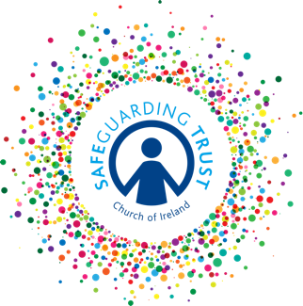
Safeguarding Trust

Parishes of Booterstown and Carysfort with Mount Merrion

St Philip and St James’ Church Booterstown and St Thomas’ Church Mount Merrion

The incumbent, select vestries, clergy, staff and volunteers are committed to uphold good practice in the parishes’ ministry with children.

Should you have a concern, suspicion or allegation regarding child welfare in the parishes, please contact a member of the parish panel.

1. Rev Canon Gillian Wharton Telephone: 087-2300767

2. Ms Jill Lacey Telephone: 086-8321100

3. Mr Damian Phelan Telephone: 087-9417000

The duty social worker may be contacted at the local Tusla Child and Family Agency office.

Duty Social worker
Tusla
c/o HSE Primary Care Centre
Unit 9, Nutgrove Retail Park,
Churchtown, Dublin 14

Telephone: 01–9213400 (direct line)

Or contact Tusla Head Office, St John’s Road, Dublin 8. Telephone: 01-7718500

Email: info@tusla.ie Website www.tusla.ie

In an emergency contact Blackrock Garda station on phone number 01-6695200

